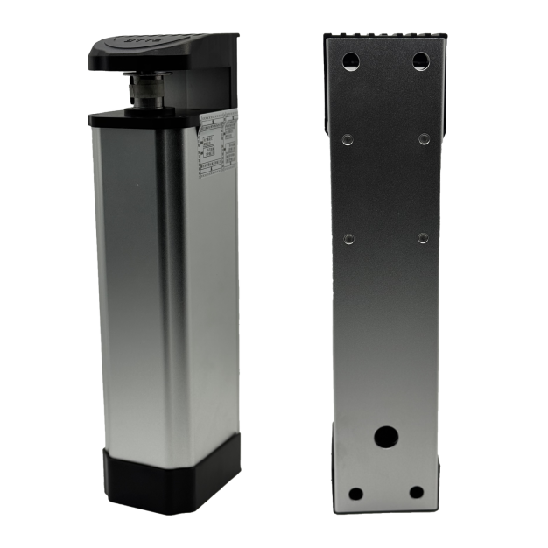
Specification of side-mounted swing door operator
Item | Parameter | Remark
Working voltage | 220VAC±15% 50Hz
Motor operating voltage | 24VDC
Power of motor | 60W
Rated output torque | 40Nm
Angular speed | 69.7°/s
Maximum opening Angle | ±90°
Maximum length of door leaf | 1.5m (single door)
Maximum weight of door leaf | 200kg
Thermal protection on motor winding | F Class 155℃
Operating frequency | Continuous running below 70℃
Operating ambient temperature | -25-70℃
Working environment | Indoor or sheltered outdoor environments
Running noise | ≤60dB
Temperature rise | ≤15℃
Weight of equipment packaging | 6.4kg
Body size (length * width * thickness) | 89.6*355.7*105.7mm
Packing size | 400*280*110mm

